Booth Deletions vs Alliance Outcomes — Extended Summary
Date: 08-Sep-2025

Win shares by deletion bin

SNO | Deletions in  booth | Deleted_  Voters | Booths | Booths_IN  _FORM20 | INDIA_won  _Booths | NDA_won  _Booths | OT__won  _Booths
1 | 1 to 49 | 7,24,078 | 23,780 | 23,613 | 9,481 | 11,331 | 2,801
2 | 50 to 99 | 21,68,473 | 29,872 | 29,652 | 11,599 | 14,613 | 3,440
3 | 100 to 149 | 18,19,721 | 15,055 | 14,955 | 5,687 | 7,625 | 1,643
4 | 150 to 199 | 9,72,314 | 5,712 | 5,676 | 2,036 | 3,063 | 577
5 | 200 to 249 | 4,61,266 | 2,093 | 2,083 | 728 | 1,154 | 201
6 | 250 to 299 | 2,03,652 | 752 | 744 | 252 | 427 | 65
7 | 300 to 349 | 98,488 | 307 | 305 | 95 | 180 | 30
8 | 350 to 399 | 46,040 | 124 | 123 | 37 | 68 | 18
9 | 400 to 449 | 33,143 | 79 | 79 | 15 | 54 | 10
10 | 450 to 499 | 16,010 | 34 | 33 | 12 | 17 | 4
11 | 500 to 549 | 6,715 | 13 | 13 | 4 | 7 | 2
12 | 550 to 599 | 3,997 | 7 | 7 | 0 | 7 | 0
13 | 600 to 649 | 4,360 | 7 | 7 | 2 | 5 | 0
14 | 650 to 699 | 1,369 | 2 | 2 | 0 | 1 | 1
 |  | 65,59,626 | 77,837 | 77,292 | 29,948 | 38,552 | 8,792

Executive Summary
Across 77,292 booths with alliance coding, overall win shares are:
- INDIA 38.7%,
- NDA 49.9%,
- OT 11.4%.

- There is a consistent gradient across deletion bins: as deletions-per-booth increase, INDIA’s win share decreases while NDA’s increases.

- This gradient is visible both at fine-grained bin level (SNO 1–14) and in aggregated buckets (Low 1–99, Mid 100–249, High ≥250).

- Statistical signal: correlation of bin midpoint with INDIA win share = -0.74 (negative), with NDA win share = 0.48 (positive).

- Operationally, low-deletion booths appear more competitive; mid/high-deletion booths show a widening NDA edge. This can inform prioritization, verification, and outreach strategies.
Detailed Findings by Bin
The table at the top lists each deletion bin (SNO), coded booth counts, and alliance win shares. Two patterns are notable:
(1) INDIA’s share declines monotonically from low to high deletion bins;
(2) NDA’s share increases correspondingly. Extreme bins (≥300 deletions/booth) have fewer booths and should be interpreted with caution.

Visuals
Win share by deletion bin (SNO):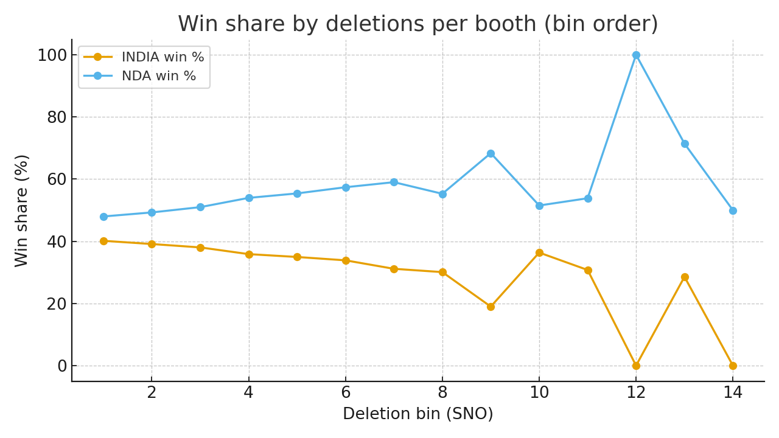
Booths counted by deletion bin:
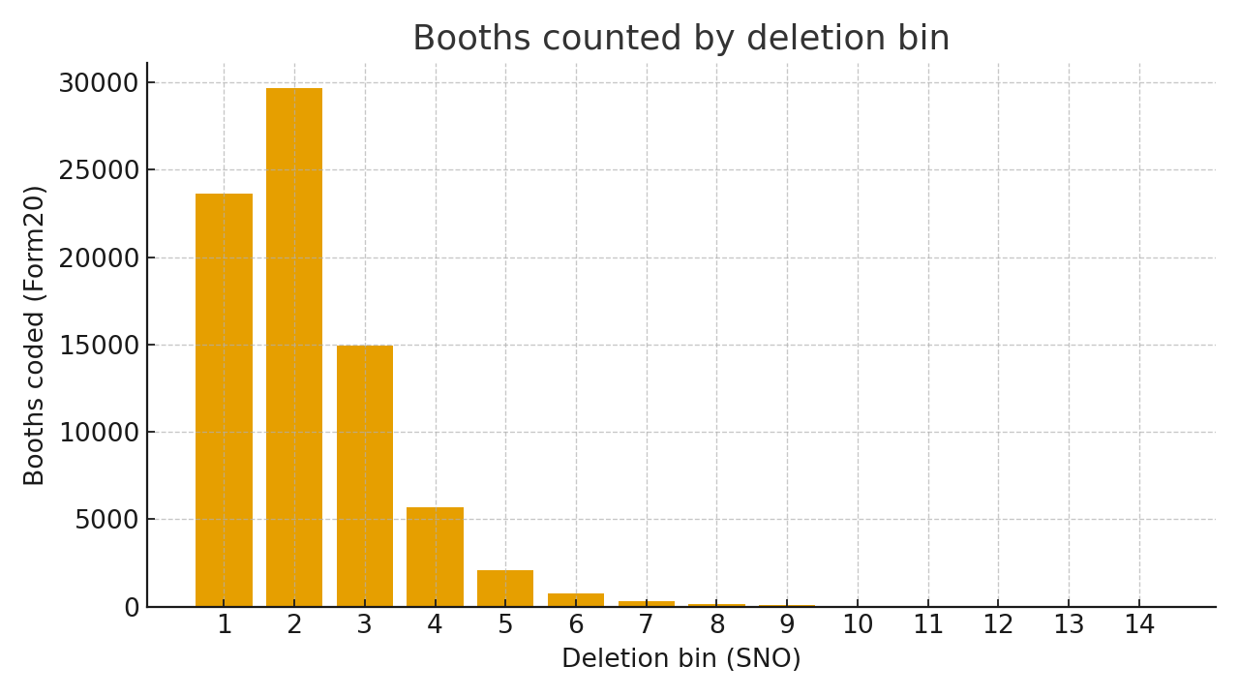

Aggregated Buckets (Low / Mid / High)
Bucket | Booths (Form20) | INDIA win % | NDA win % | OT %
Low (1–99) | 53,265 | 39.6% | 48.7% | 11.7%
Mid (100–249) | 22,714 | 37.2% | 52.1% | 10.7%
High (≥250) | 1,313 | 31.8% | 58.3% | 9.9%
Methodology & Quality Checks
- Unit of analysis: booth-level bins of deletions per booth (SNO 1–14), with winners mapped to alliances using Form20.
- Shares computed as alliance-winning booths divided by total Form20-coded booths within each bin; totals exclude uncoded booths.
- Correlation computed between bin midpoints and alliance win shares to summarize trend strength.
- Sanity checks: totals reconcile with sheet summary; bins ordered by SNO; negligible missingness within coded set.

Implications for Field & Messaging
- Prioritize audit and voter assistance in Mid/High deletion bins where NDA edge widens; investigate causes (migration, deletions quality, documentation).
- In Low bins, treat as competitive turf: emphasize booth-level GOTV and micro-messaging; leverage INDIA’s relatively stronger baseline.
- Create a monitoring dashboard by AC/PC overlaying deletion bins with INDIA/NDA performance to target resources efficiently.

Caveats
- High-deletion bins represent a small slice of total booths; results at extremes may be noisy.
- Booth ‘win’ is categorical; it does not encode margin or total turnout effects.
- No geographic controls are applied here; localized dynamics may differ across districts.

